Austin Stephens

Assignment 3

2/7/16

1. My code successfully checks to see if the user entered a digit between 1 and 10 and then compares that digit with a randomly generated digit of the same range. If the user digit matches the random digit then it returns a success statement, if not it returns a failure statement.

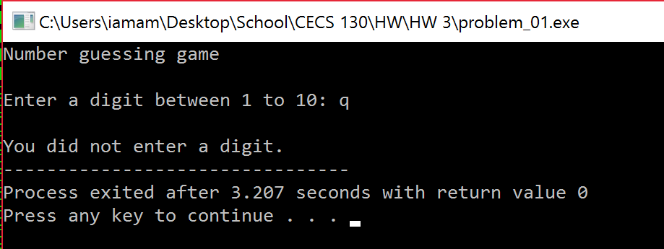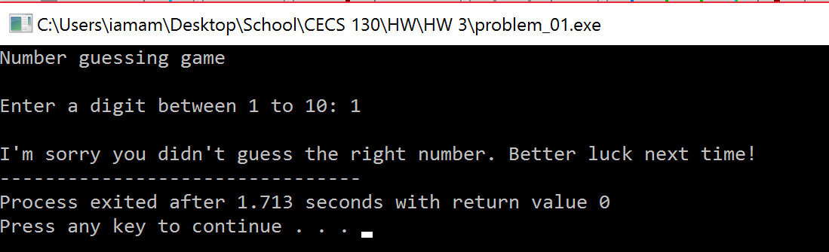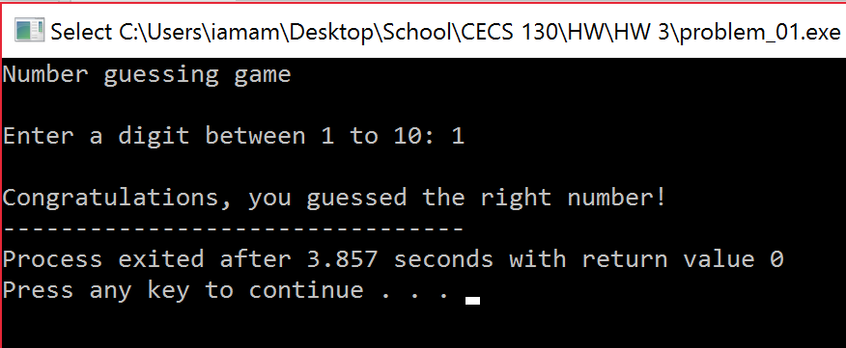

3. My code successfully simulates rolling two dice. If the sum of the two dice is 7 or 11 the program outputs a win statement, if the sum is any other number the program outputs a lose statement.

